# CS 255 System Design Document

## UML Diagrams

### UML Use Case Diagram

### UML Activity Diagrams

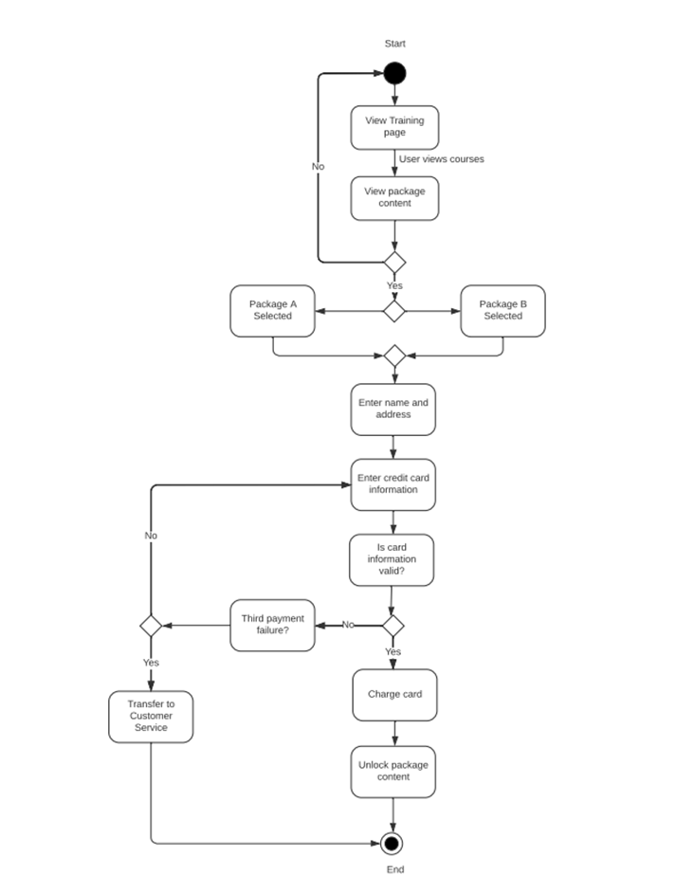

### UML Sequence Diagram

### Diagram Description automatically generatedUML Class Diagram

## Technical Requirements

Hardware requirements for Host:

* At least one physical server
* Network cables for server and equipment
* Monitor, keyboard, and mouse
* Power source
* Internet source

Hardware requirements for Client:

* Computer – desktop or laptop
* Wireless card or ethernet cable for networking
* Power source
* Internet source

Software requirements for Host:

* Supported operating system
* DriverPass Software
* Docker software for controlling VM traffic
* Security software

Software requirements for Client:

* Web browser
* Operating system
* Security software